1)In order to turn ON this Click board™, the user has to press the onboard push-button labeled as
PWRKEY down for a period longer at least 500ms, which represents the Ignition (Power-On) button.

2) It supports automatic baud rate detection, operates at 115200 bps by default configuration,
and is used for data transmission and exchanging AT commands with the host MCU.

USIM Interface : Support 1.8V USIM card

3)pin definitions
BC66-NA is equipped with a total of 58 pins, including 44 LCC pins and 14 LGA pins

Power Supply Pins BC66-NA provides two VBAT pins for connection with an external power supply. The table below describes the module's VBAT and ground pins.

PIN NO | Name
1, 27, 34, 36, 37, 40, 41 | GND
7 | PWRKEY
15 | RESET (ACTIVE LOW)
18 | RXD
17 | TXD
42 | VBAT_BB (power supply for module baseband part)
43 | VBAT_RF (power supply for module RF part)

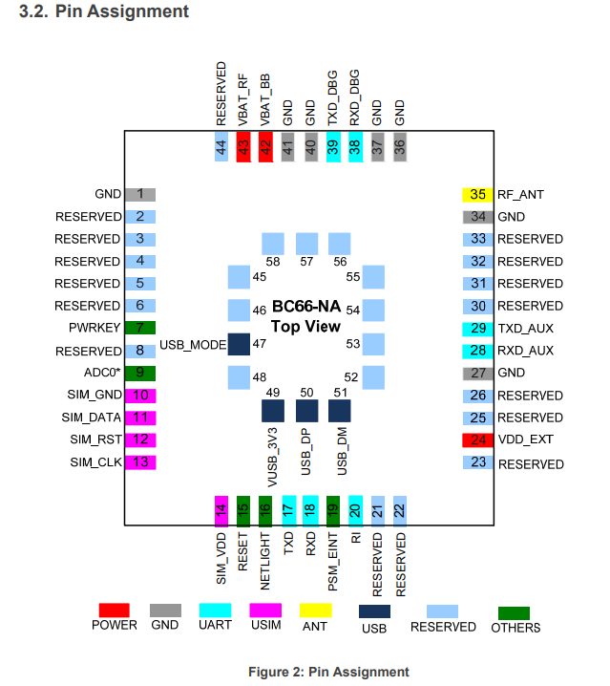

AT+CTZU=1 ----> Enable automatic time zone update

AT+CCLK=1 ----> Get current time

AT+QCCLK ----> set and get current date time and UTC

AT+CGSN=1 ----> for requesting imei no

AT+CSQ -------> signal strength

List of TCP/IP command:

List of TCP/IP Related AT Commands

AT Command Description
[1] AT+QIOPEN Open a Socket Service *
[2] AT+QICLOSE Close a Socket Service *
[3] AT+QISTATE Query Socket Service Status
[4] AT+QISEND Send Hex/Text String Data *
[5] AT+QIRD Retrieve the Received TCP/IP Data
[6] AT+QISENDEX Send Hex String Data
[7] AT+QISWTMD Switch Data Access Modes
[8] AT+QPING Ping a Remote Server
[9] AT+QNTP Synchronize Local Time through NTP Server
[10] AT+QIDNSGIP Get IP Address by Domain Name
[11] AT+QIDNSCFG Configure DNS Server Address
[12] AT+QICFG Configure Optional Parameters
[13] AT+QIGETERROR Query the Last Error Code

List of SSL Related AT Commands

[1] AT+QSSLCFG Configure Parameters of an SSL Context
[2] AT+QSSLOPEN Open an SSL Socket to Connect a Remote Server
[3] AT+QSSLSEND Send Data through SSL Connection
[4] AT+QSSLCLOSE Close an SSL Connection

